Daily NSE Stock & Options Report App – Product Requirements Document

1. Executive Summary and Goals
This product delivers a daily, data-driven options report for Indian markets (NSE). It targets active traders (intraday, derivatives), proprietary trading desks, and retail investors. Key goals are to provide a concise pre-market briefing with actionable analytics: index trends, options chain insights, stock signals, and macro cues. Users (traders/analysts) can quickly gauge market bias, identify opportunities, and manage risk each morning. The app must reliably fetch and synthesize NSE equity/derivatives data, global indicators (US indices, crude, USD/INR), volatility (India VIX), and FII/DII flows into an easy-to-digest daily report.

2. Features & Prioritization
- Core (MVP): Real-time market data ingestion (NIFTY 50, BANK NIFTY, FINNIFTY quotes, options chain with CE/PE OI, IV, PCR, Max Pain); India VIX; FII/DII net flows; global cues (US indexes, SGX Nifty, Brent oil, USD/INR); automated daily report generation (JSON export and on-screen summary); basic dashboard (index cards, watchlist).
- Version 1: User accounts and roles (trader, admin), scheduling (daily email/SMS notification), watchlist customization, alerts/notifications (e.g. index breakout, custom stock triggers), strategy builder UI (predefined spreads, straddles). JSON report API endpoint (see Data Models).
- Version 2: Advanced analytics (AI insights, custom scans), historical backtesting of strategies, multi-day reports (weekly), collaboration/sharing, mobile app support, audit logs for data retrieval and user actions.
Feature | Description | Priority
NSE Indices & Stocks data | Live NIFTY50/BANKNIFTY/FINNIFTY quotes, volumes, daily OHLC | MVP
Options Chain | CE/PE open interest, change, implied volatility, PCR, Max Pain | MVP
FII/DII Flow | Daily net positions in equity and derivatives[1] | MVP
India VIX | Volatility index (NIFTY) | MVP
Global Cues | US market indices (S&P500, Nasdaq), SGX Nifty futures, Brent crude[2], USD/INR[3] | MVP
Dashboard UI | Summary cards for indices/VIX, interactive charts (index, option chains) | MVP
JSON report export/API | Endpoint for daily report JSON matching specification | MVP
Watchlists & Alerts | Custom stock lists, breakout/volatility alerts | v1
Strategy Builder | Interactive tool for building high-prob trades (straddles, spreads) | v1
Scheduling & Notifications | Automated report delivery (email/SMS) at market open | v1
User Accounts & Roles | Authentication (OAuth2/JWT), RBAC | v1
Audit & Logging | Track data-fetch activities and user actions | v1
Analytics & History | Historical analytics, backtesting module | v2
Collaboration (Sharing) | Share insights/report, team roles | v2

3. Data Architecture
- Sources & APIs:
- NSE India: Official data for indices, equities, options, FII/DII. For example, NSE publishes end-of-day FII/DII CSVs[1]. Exchange APIs (or licensed feeds) provide indices and option chains. The stock-nse-india tool demonstrates available NSE endpoints (equity data, indices including option chains)[4].
- India VIX: Via NSE (custom API or scraped values) or financial feeds (e.g. Kotak NEO)[5].
- Global Data: Alpha Vantage or Yahoo/Exchange APIs for US indices, commodity (Brent WTI) prices, forex. For example, Alpha Vantage offers commodities (Crude Oil WTI/Brent) and FX endpoints[2][3].
- SGX Nifty: Singapore Exchange data (NIFTY futures on SGX) via SGX APIs or chart sources.
- Data Ingestion:
- Likely polling schedule (e.g. every minute or on-demand) for live intraday data; batch at EOD/pre-open for summary metrics. Real-time streaming (websocket) may be used for ticker updates if licensed (many official feeds are multicast tick feed[6]).
- Caching: Persist raw quotes and computed values in a database (e.g. time-series DB + relational store). In-memory caches (Redis) for latest index values to speed up frontend.
- Data Retention: Store detailed time-series for last 1+ year for historical reference. Summary records (daily open/close/OI) indefinitely for trend analysis.
- Processing:
- ETL pipeline: Normalize incoming feeds (NSE, third-party). Compute indicators (PCR, Max Pain, volatility measures).
- Fallback Rules: If a source fails, label fields "data not available" in output JSON. For example, if FII feed is missing, still generate report with notice (as per spec) and log error.
- Data Reconciliation: Cross-check similar metrics (e.g. NIFTY level from NSE vs vendor) to detect anomalies. Log discrepancies for QA.
- Mermaid: System Architecture
graph LR
A[NSE & Market Data Sources] --> B(Data Ingestion Service)
C[Global Data APIs] --> B
B --> D[(Database / Cache)]
B --> E[Compute Engine (analytics)]
D --> F[Web Backend / API Server]
E --> F
F --> G[Web/Mobile Frontend]
E --> H[Notification/Alert Service]
H --> I[Email/SMS Service]

4. Data Models & JSON Schema
The daily report output JSON includes the specified sections. Example schema (TypeScript-like) and sample payload:
{
"market_overview": {
"global_markets": [
"US indices record-highs (Dow up 1.62%, S&P500 +1.02%)[4]",
"SGX Nifty up 0.7% (bullish pre-open)",
"Crude ~\$114 (+3.7%)[2]; USD/INR ~94.8"
],
"india_opening_bias": "Bullish",
"macro_factors": [
"Fed meeting this week (dovish expected)",
"Crude oil surge (inflation watch)",
"Rupee weakness vs USD"
]
},
"index_analysis": {
"NIFTY 50": {
"trend": "Range-bound",
"support": [23751, 23598],
"resistance": [24244, 24397],
"PCR": null,
"max_pain": null,
"OI_build_up": null,
"intraday_bias": "Neutral/Bearish"
},
"BANK NIFTY": {
"trend": "Consolidation (bearish bias)",
"support": [54132, 53679],
"resistance": [55595, 56048],
"PCR": null,
"max_pain": null,
"OI_build_up": null,
"intraday_bias": "Neutral/Bearish"
},
"FINNIFTY": {
"trend": "Weak (down)",
"support": [27358, 26986],
"resistance": [28559, 28931],
"PCR": null,
"max_pain": null,
"OI_build_up": null,
"intraday_bias": "Bearish"
}
},
"options_chain": {
"highest_call_OI": "Strikes ~24400–24600 (resistance zone)",
"highest_put_OI": "Strikes ~23500–23600 (support zone)",
"OI_change": "Call accumulation, modest put-selling",
"smart_money": "Heavy FII selling (–₹8048cr)[1], DIIs +₹3487cr"
},
"stocks": [
{
"symbol": "BAJAJ-AUTO",
"reason": "Bullish breakout (↑5.2%)[4] on high volume",
"levels": {"entry": 4200, "stoploss": 4100, "target": 4500},
"options_strategy": "Buy 4200 CE (bull call)"
}
/* additional stock objects */
],
"strategies": [
{
"name": "Nifty Iron Condor",
"type": "Neutral",
"details": "Sell 24500CE & 23500PE, buy 24700CE & 23300PE (July expiry). Limited-risk range trade[4].",
"entry": 24100,
"strike_selection": "Sell 24500CE/23500PE; buy 24700CE/23300PE",
"risk_reward": "Limited",
"market_condition": "Range-bound"
}
/* additional strategies */
],
"fii_dii": {
"net_FII": -8048,
"net_DII": 3487,
"analysis": "FIIs sold ~₹8048cr on Apr 30[1]; DIIs bought ₹3487cr. Net selling pressure."
},
"volatility": {
"India_VIX": 18.46,
"change": "+5.85%",
"interpretation": "Moderate volatility (VIX ~18.5)[5], ~200pt Nifty range expectation.",
"expected_range": "~23900–24500"
},
"trading_plan": {
"best_case": [
"Nifty holds >24,200 and rallies above 24,500 (bullish continuation).",
"BankNifty >55,000 moves to ~56,300."
],
"worst_case": [
"Nifty breaks <23,800, falling to ~23,500.",
"BankNifty <54,600 (supports breached)."
],
"no_trade_zone": [
"Nifty trades 23,950–24,200 range – avoid new bets until breakout."
],
"summary": "Range-bound bias; sell on rallies near resistance unless Nifty decisively breaks out[4]."
}
}
API Endpoints (REST) – Sample mapping:
Endpoint | Method | Description | Request (JSON) | Response (JSON)
/api/report/daily | GET | Fetch daily report for given date | { "date": "YYYY-MM-DD" } (or query parameter) | Daily report JSON (as above) or error object
/api/stocks/watchlist | GET/POST | Manage user watchlist | ["RELIANCE","TCS"] | Current watchlist / OK
/api/alerts | POST | Create alert rule (e.g. breakout) | { "symbol":"NIFTY", "type":"breakout", "threshold":24200 } | Confirmation / error
/api/strategies/simulate | POST | Simulate a strategy pay-off chart | { "type":"ironCondor", "strikes":[24500,23500], "premium": ... } | Simulation results JSON
Sample Daily Report Request/Response:
GET /api/report/daily?date=2026-05-01
Response 200 OK:
{
"market_overview": { ... },
"index_analysis": { ... },
/* etc. */
}
Response 400 Bad Request:
{ "error": "Invalid date format or data unavailable" }

5. UX/UI Design
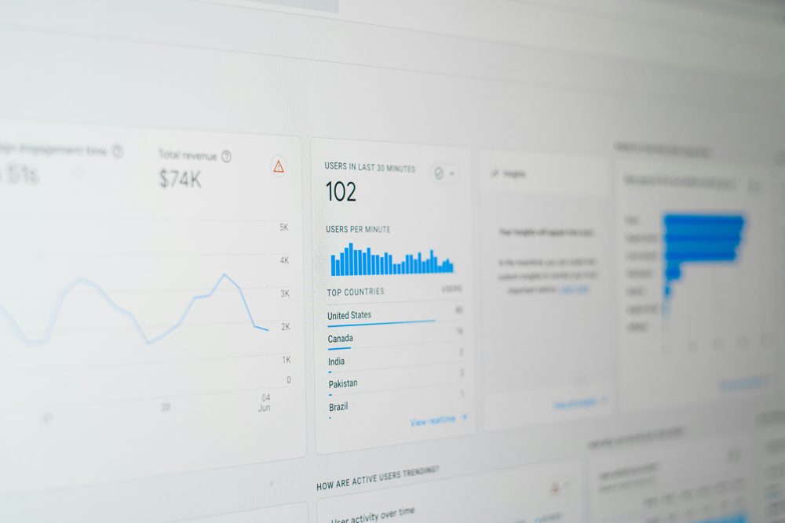
Figure: Example dashboard displaying indices, VIX, and options chart (mockup). The app will feature a dashboard summarizing market status (NIFTY, Bank Nifty, VIX, global cues) with visual charts (intraday line chart, OI heatmap). A report composer page presents the generated daily report (accordion or sections for each category). Users can click into a stock detail view for charts and options chain of individual stocks. An options chain viewer UI will show strikes, OI, and IV with filter/sort. The strategy builder page lets users select strategy type (iron condor, straddle, etc.), choose strikes and expiry, and preview payoff/RR. Layouts will be responsive: desktop web and mobile app share components. Notifications (pop-ups, email/SMS) will follow platform UX conventions.

6. Update Cadence & SLAs
- Real-time data (quotes, options) updated every minute during market hours; UI shows last-updated timestamp.
- Daily report generation: scheduled ~8:00 AM IST each trading day (after pre-open data available), with <1 minute processing time goal.
- Latency targets: backend fetch latency <5s per source; end-to-end API response <500ms.
- Retries & Backoff: Automated retry (3 attempts) on transient API failures with exponential backoff.
- Freshness Indicator: Dashboard shows “Last updated X sec ago”; red highlight if data older than 5 minutes.

7. Security, Compliance & Rate-Limiting
- Authentication: OAuth2 login (or JWT) for user accounts; API key for partner access.
- Encryption: TLS for all data in transit; sensitive data (API keys) encrypted at rest.
- Rate Limiting: Throttle outbound API calls per provider limits (e.g. Alpha Vantage free tier limits ~5 calls/min). Implement 429 handling and fallback.
- Data Licensing: Comply with NSE Data Sharing Policy[7] – obtain necessary licenses for redistributing NSE data. Include NSE attribution (via link/logo in UI).
- User Privacy: Store only necessary user data; GDPR-equivalent policies (though India-based).
- Audit Log: Track data fetch jobs and user actions for compliance.

8. Testing & Monitoring
- Unit & Integration Tests: Cover data parsing, business logic, report generation (using Jest/PyTest).
- Synthetic Data Feeds: Simulate missing/bad data scenarios; ensure fallback (fields = "data not available").
- Monitoring Dashboards: Track API health (uptime, error rates), data freshness, and queue lengths (e.g. via Grafana).
- Alerts: Trigger on failed data pulls or report generation (>1 consecutive failure).
- Sample SLA: ≥99.5% uptime; email alert if failed report >1 hour after scheduled time.

9. Operational Runbook
- Incident Response: On data-source outage, switch to cached values or mark metrics unavailable. Page should display “Data not available” flags.
- Failover: If primary API fails, optionally use backup (e.g. Yahoo finance as fallback for index quotes).
- Degraded Mode: Partial report possible – e.g., if FII data missing, still send market overview and stocks sections with note.
- Rollback Plan: CI/CD pipeline with versioned releases; database rollbacks if schema issues.
- Maintenance Windows: Off-hours (weekends) for major upgrades.

10. Metrics & KPIs
- Uptime: 99.5%+ (excluding scheduled maintenance).
- Data Freshness: 95% of data points <2 min stale.
- Report Latency: <1 minute from trigger to API output for daily report.
- User Engagement: Daily active users, number of reports generated.
- Accuracy: <1% discrepancy in key figures (cross-validate with exchange figures).

11. Roadmap & Estimates
Milestone (3-mo MVP) | Deliverables | Team & Effort (FTE-weeks)
Data Ingestion (NSE indices, stocks) | Implement data fetch jobs; design DB schema | 2 devs × 4w
Options Chain & Analytics | Fetch option OI, IV; compute PCR, Max Pain | 2 devs × 4w
Dashboard UI (Web) | Basic index cards, charts; responsive layout | 2 devs + 1 designer × 6w
JSON Report API & Schema | API endpoint, output matching schema above | 1 dev × 2w
FII/DII & VIX Integration | Parse NSE FII CSV; fetch VIX; integrate on dashboard | 1 dev × 2w
Deployment & QA | CI/CD pipeline, tests, staging release | 2 devs + 1 QA × 3w

Milestone (6-12 mo full) | Deliverables | Team & Effort
Alerts & Notifications | Rule engine, email/SMS integration | 2 devs × 4w
Watchlists & Strategy Builder | UI for user watchlist, strategy simulations | 2 devs + 1 designer × 6w
User Auth & Roles | OAuth2 integration, admin UI, audit logs | 1 dev × 3w
Mobile Responsive/Apps | Mobile web redesign, native app prototyping | 2 devs × 6w
Advanced Analytics | Backtesting module, AI insights, history UI | 2 devs × 8w
Assumptions: India-based hosting, small initial user base (<5k), budget for premium data (NSE license) as needed.

12. Acceptance Criteria & QA Checklist
- Data Accuracy: Spot-check output vs NSE published values (indices, futures, FII figures).
- Report Structure: All sections (market_overview, index_analysis, etc.) present even if empty.
- API Contract: JSON keys/types match schema, HTTP statuses correct (200/400/500).
- UI/UX: Key workflows (login, view report, add alert, build strategy) work on Chrome/Safari/Firefox.
- Performance: Report generation within defined latency; UI loads within 2s.
- Security: No sensitive data leak; OWASP basic scan passed.
- Error Handling: Simulate missing data (e.g. no internet); app logs error and shows “data not available”.

[1] FII/FPI & DII trading activity on NSE, BSE and MSEI Reports - NSE India
https://www.nseindia.com/reports/fii-dii
[2] [3] API Documentation | Alpha Vantage
https://www.alphavantage.co/documentation/
[4] GitHub - hi-imcodeman/stock-nse-india: API for National Stock Exchange of India (NSE) · GitHub
https://github.com/hi-imcodeman/stock-nse-india
[5] India VIX Today (INDEXNSE: INDIA_VIX) | Live Chart & Market Volatility
https://www.kotakneo.com/indices/indian-indices/india-vix/
[6] Real Time Data - NSE India
https://www.nseindia.com/static/market-data/real-time-data-subscription
[7] NSE - National Stock Exchange of India Ltd.
https://www.nseindia.com/static/market-data/nse-data-policy

